Overall churn rate

select
count(*) as total_customers,
sum( case when exited = 1 then 1 else 0 end ) as churned_customers,
round(sum(case when exited = 1 then 1 else 0 end )*100/count(*), 2) as churn_percentage
from Churn_Modelling
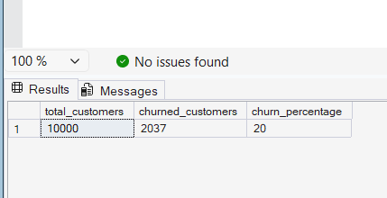

Churn by Geography
select
Geography,
count(*) as total_customers,
sum(case when exited = 1 then 1 else 0 end ) as churned,
round(sum( case when exited = 1 then 1 else 0 end )*100/count(*) , 2 ) as churn_rate
from Churn_Modelling
group by Geography
order by churn_rate desc
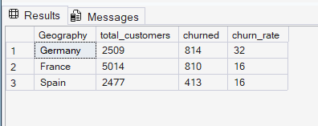

Group by gender
select
Gender,
count(*) as total,
sum( case when exited = 1 then 1 else 0 end ) as churned,
round( sum( case when exited = 1 then 1 else 0 end )*100 / count(*) , 2 ) as churn_rate
from Churn_Modelling
group by gender
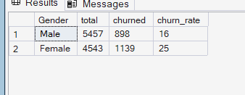

Avg balance of churned vs retained
select
Exited,
avg(Balance) as avg_balance
from Churn_Modelling
group by Exited
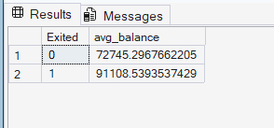

Credit score impact
select
case
when CreditScore < 500 then 'Low'
when CreditScore between 500 and 700 then 'Medium'
else 'High'
end as credit_category,
count(*) as total,
sum( case when exited = 1 then 1 else 0 end) as churned
from Churn_Modelling
group by
case
when CreditScore < 500 then 'Low'
when CreditScore between 500 and 700 then 'Medium'
else 'High'
end
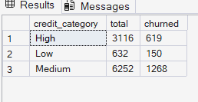

Active vs inactive customers
select
IsActiveMember ,
count(*) as total,
sum(case when exited = 1 then 1 else 0 end ) as churned
from Churn_Modelling
group by IsActiveMember
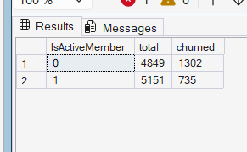

Ranking customers by balance
select
CustomerId,
Balance,
rank() over ( order by balance desc ) as balance_rank
from Churn_Modelling
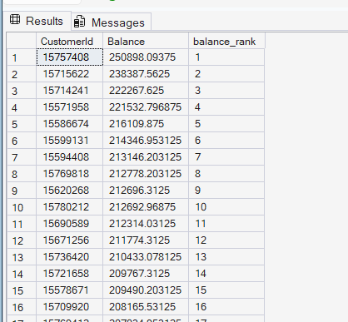
Running Total
select
CustomerId,
Balance,
sum(Balance) over ( order by CustomerId) as running_total
from Churn_Modelling
